Edward Venator and Chris Dickey

Lab 11

**Step 1**

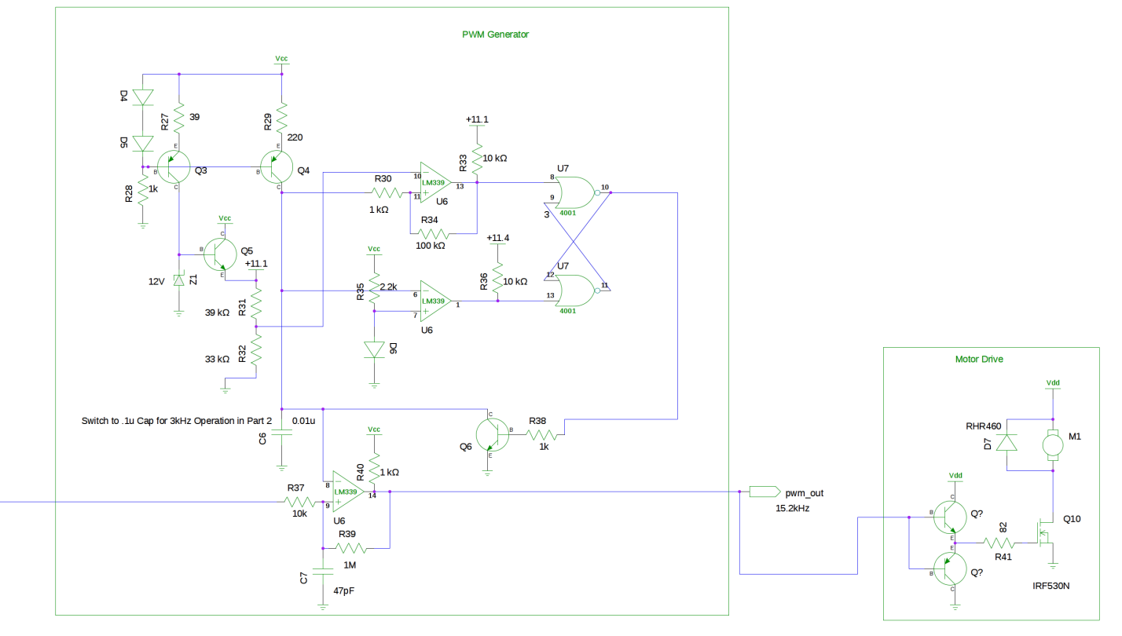

**Step 2**

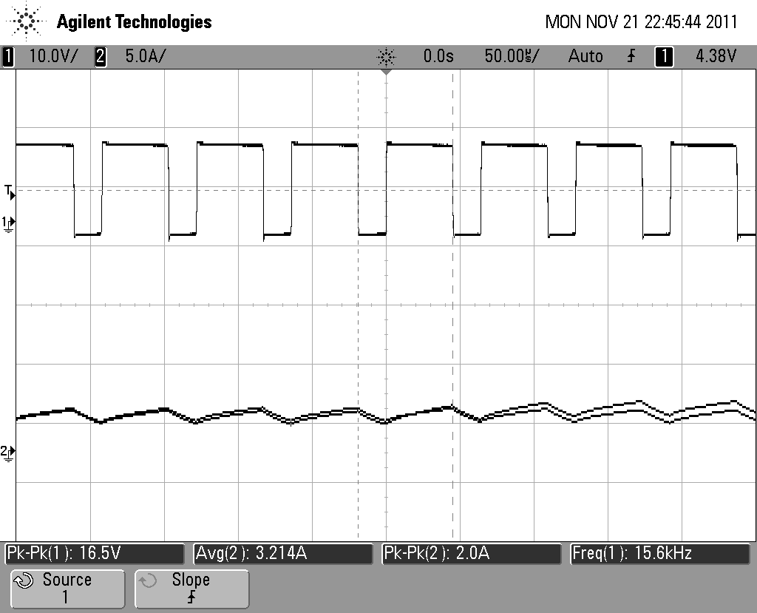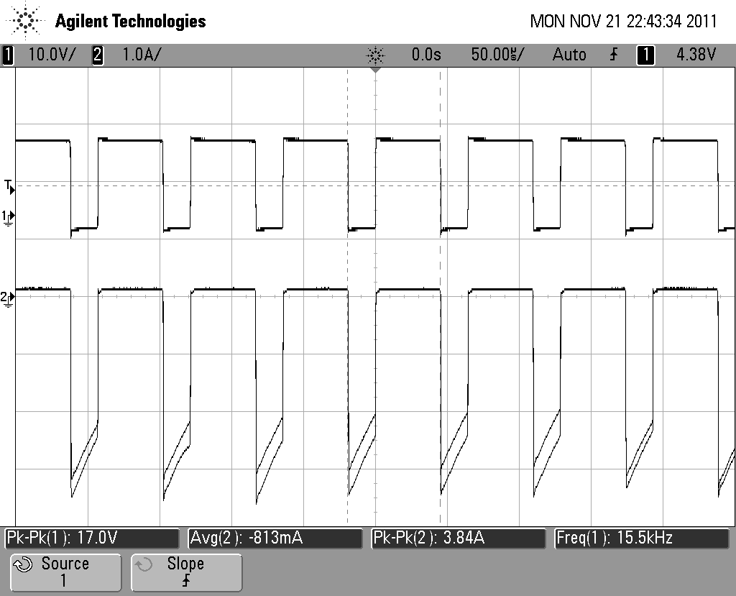

Motor Voltage and Current (no load) Motor Voltage and Diode Current (no load)

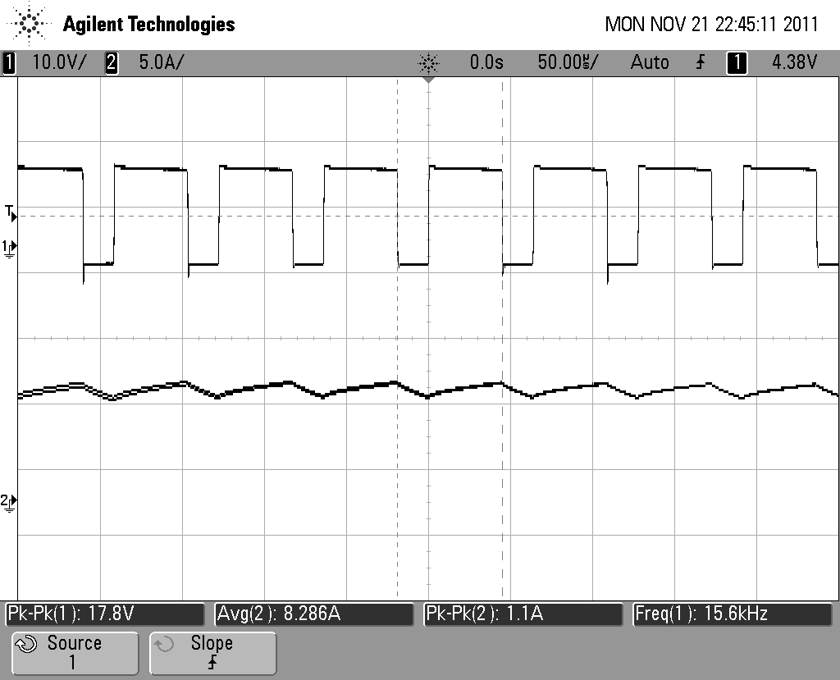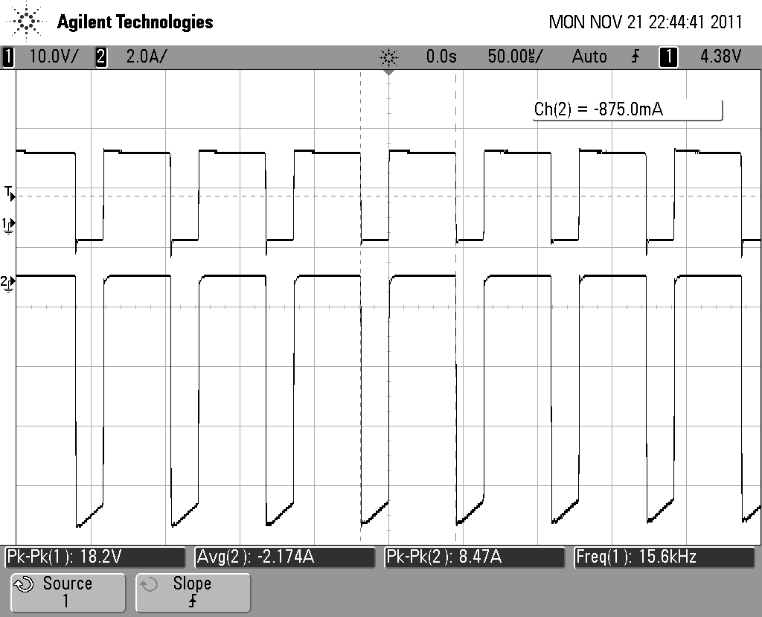

Motor Voltage and Current (full load) Motor Voltage and Diode Current (full load)

**Question 1 – Is the 1N5819 diode suitable?**

The current rating of the 1N5819 (1A) is not suitable for this application (2A) . We are using a hyperfast recovery diode rated for 4A, but it only works with a heatsink, and cannot be run at high speed without load for extended periods.

**Question 2 - What are the effects of reducing PWM freq to 2-3kHz?**

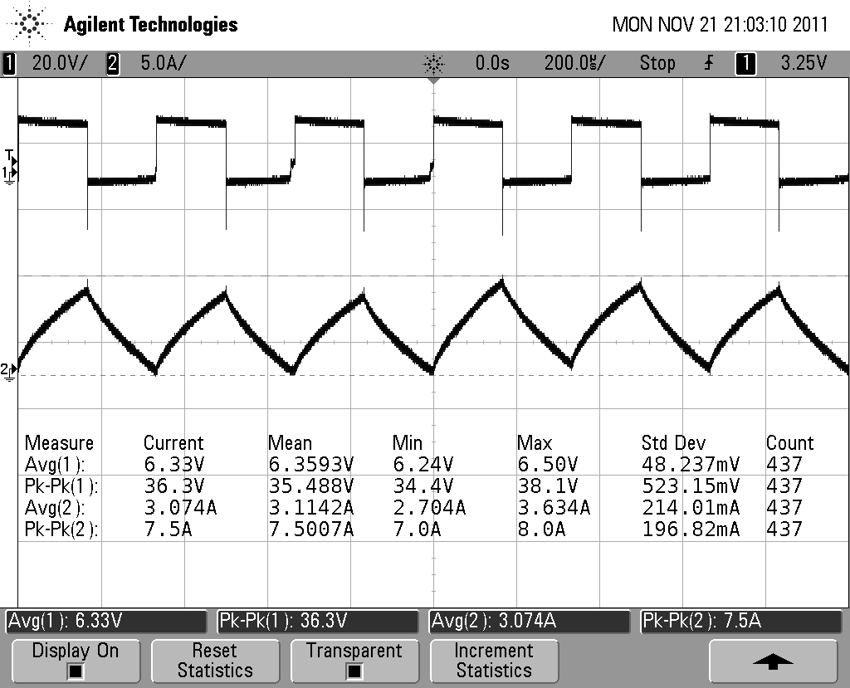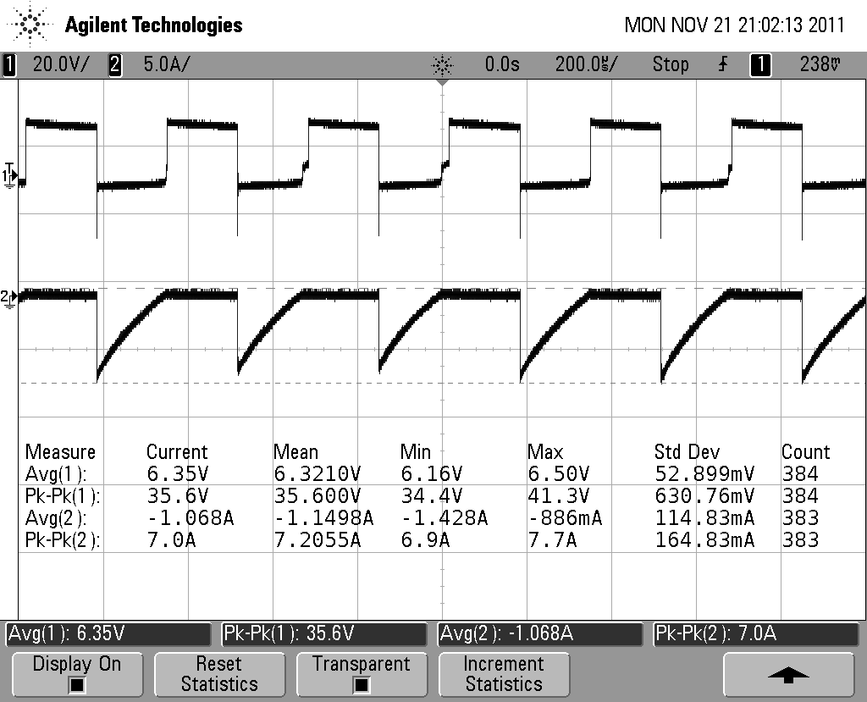 Motor Voltage and Current (3kHz) Motor Voltage and Diode Current (3kHz)

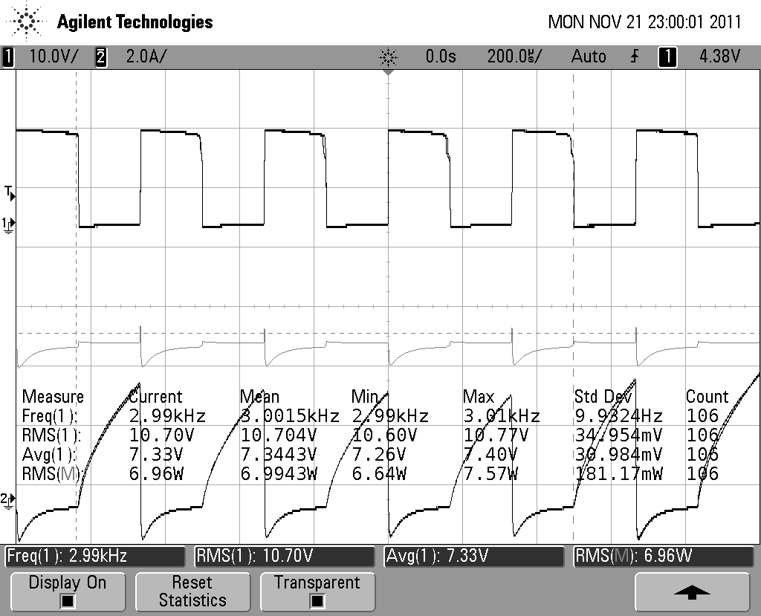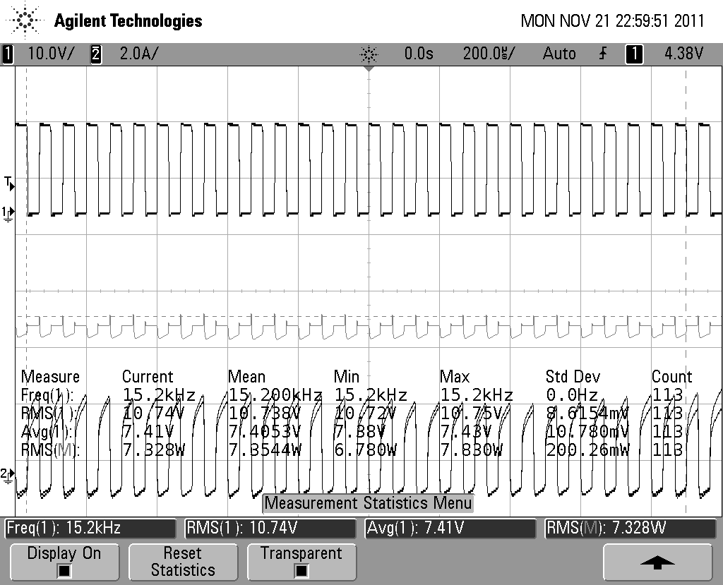

Transistor Current and Power(15kHz) Transistor Current and Power(3kHz)

Pk-Pk diode currents are much higher, and average currents are about twice as large.

Transistor Losses are about .4W less (RMS) at 15kHz.

Diode losses are about .2W more (RMS) at 15kHz.

**Question 3**

In continuous operation, the motor current never completely drops to zero (because of the diode). In discontinuous, the motor current does drop to zero.

**Question 4**

What is the heat sink requirement of the MOSFET at 8A?

Øhs-a = Øj-a - Øj-c - Øc-hs

Øhs-a = (Tj-Ta)/PD­ - Øj-c - Øc-hs

Øhs-a = (115°C-25°C)/((8A)2*.256 Ohm)­ - Øj-c - Øc-hs

Øhs-a = 5.49°C/W – 1.9°C/W - 1°C/W

Øhs-a = 2.6°C/W

**Step 3**

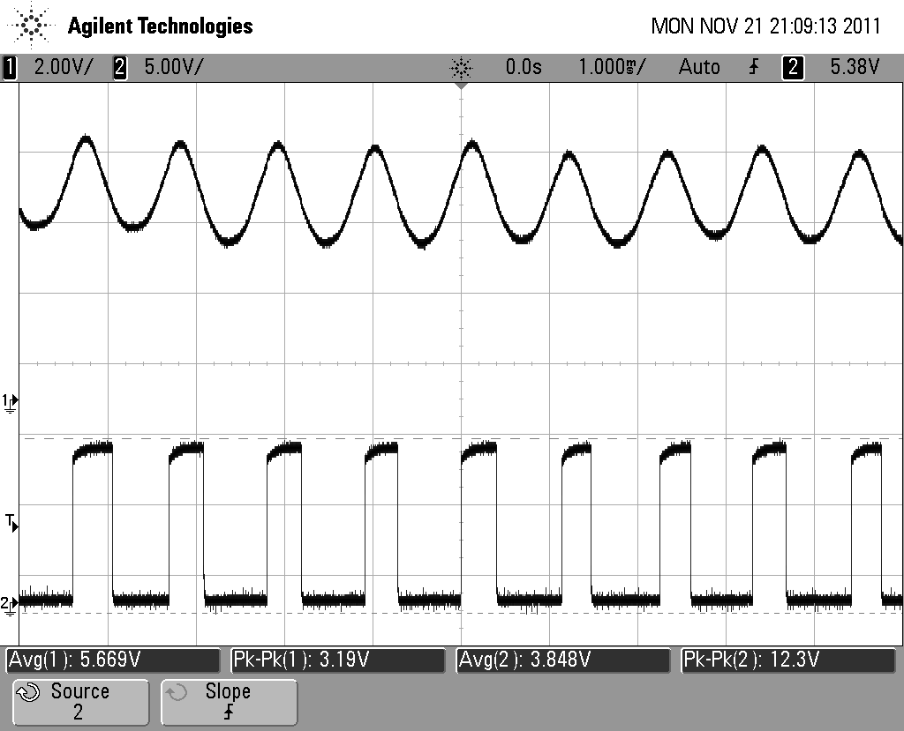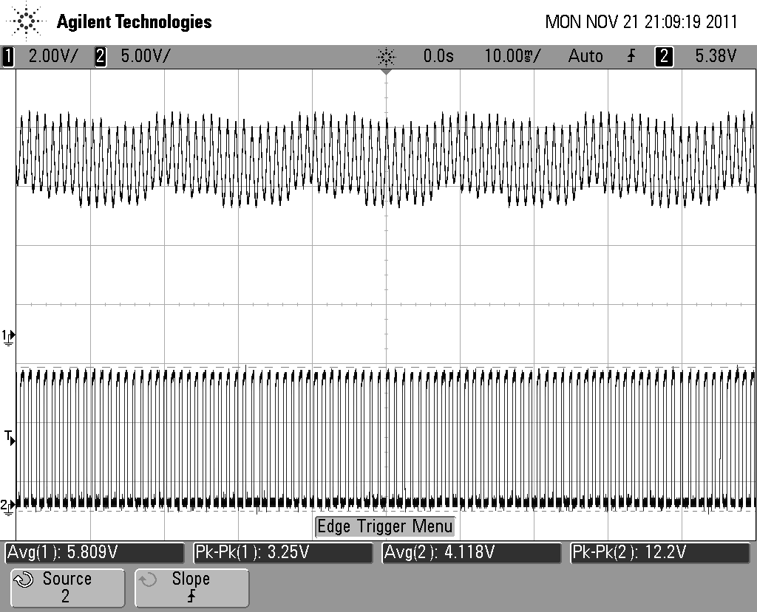

Raw Photodiode Output and Squared Output (zoom and wide angle)

**Step 4**

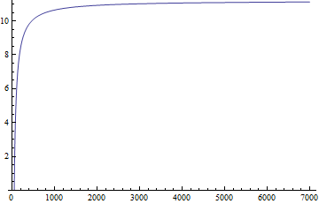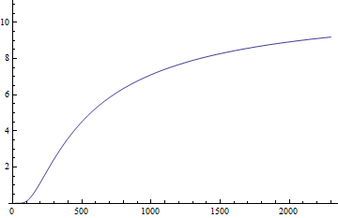

Frequency to Voltage Converter Response Curves (Constant Current Sink(L) vs Final Design(R))

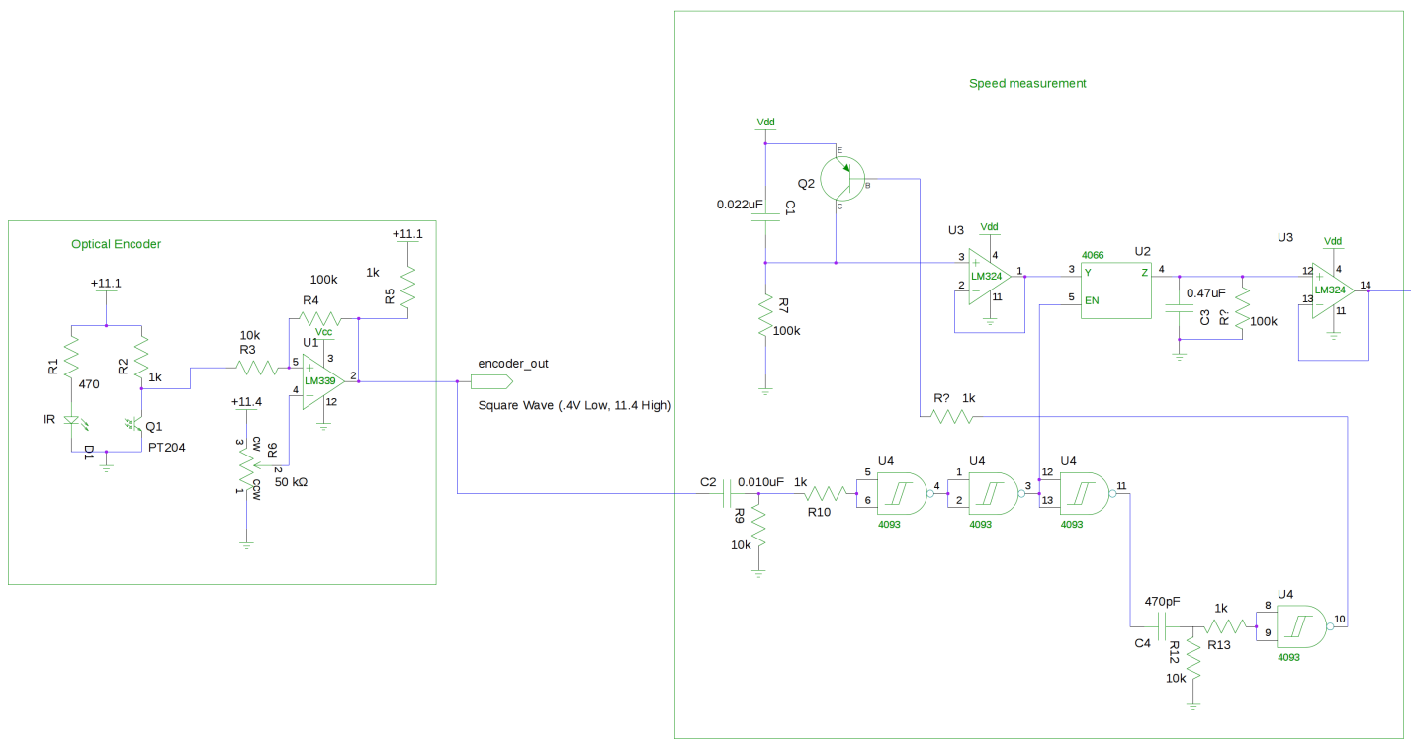

**Step 5**

|  |  |
| --- | --- |
| Load | RPM |
| 8.5A (Power Supply cuts out above here) | 4500 |
| 0 | 5820 |

Load Reg = 155 RPM/A

**Question 6**

A series resistor (aside from being a space heater) would make the speed decrease as the motor is loaded (increased current causes increased voltage drop across the resistor). This would have terrible load regulation.

**Step 6**

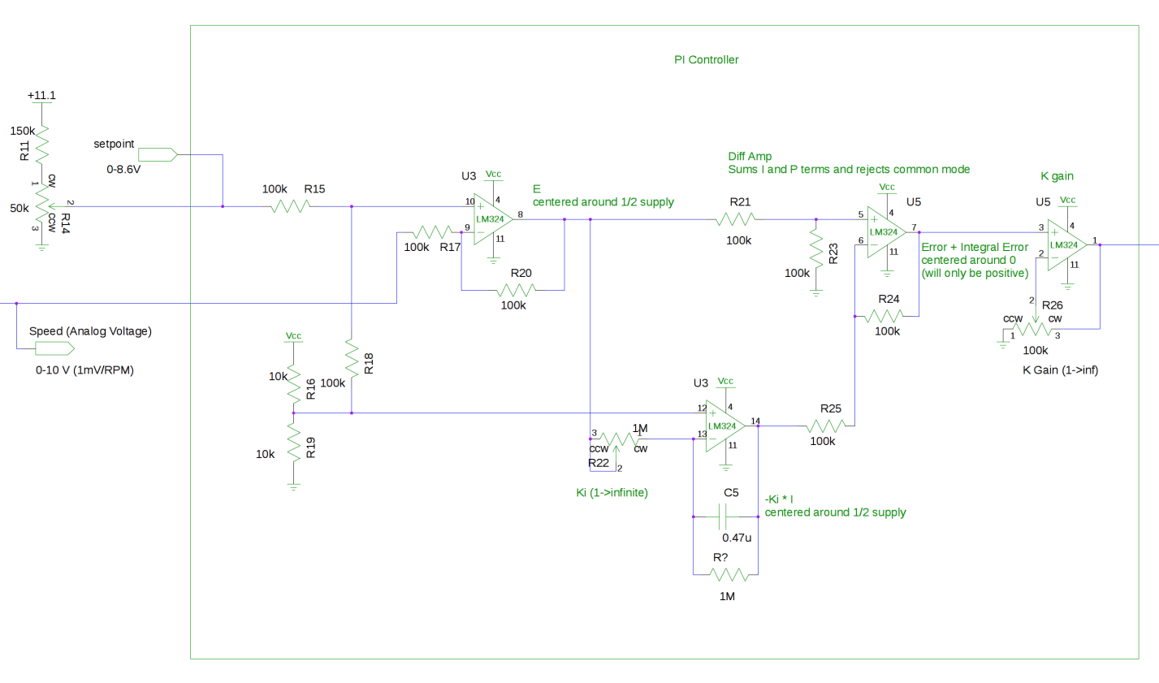

**Question 7**

Min Speed = 108 RPM

Max Speed (fl) = 4980 RPM

|  |  |
| --- | --- |
| Line Voltage | RPM |
| 12V | 3645 |
| 15V | 3654 |
| 18V | 3723 |

(All measurements at 75% speed, FL)

Line Reg =13 RPM/Volt

|  |  |
| --- | --- |
| Load | RPM |
| 6.3A (Power Supply cuts out above here) | 3672 |
| 0 | 3660 |

Load Reg = .3% (1.9RPM/Amp)

Step Response (No load->full load) = 150ms

Step Response (Full load->no load) = 150ms